WEEK 2 – POWER BI DATA ANALYSIS

Superstore Sales & Profit Analysis Dashboard
Submitted by :Priyadharshini B
Roll No : E25DA050

1. Introduction
Microsoft Power BI serves as an advanced business intelligence tool designed for analyzing and visualizing complex data streams. This project leverages the Superstore Sales Dataset to evaluate corporate metrics spanning revenue, profit performance, order volumes, product lines, customer distributions, and regional trends.

2. Project Objectives
- Conduct an in-depth analytical review of the Superstore dataset.
- Cleanse, structure, and refine raw data for optimal processing.
- Construct a robust data schema alongside a dedicated Date Table.
- Compute critical performance indicators utilizing DAX expressions.
- Evaluate financial performance across diverse product segments and geographic zones.
- Develop an end-to-end interactive reporting dashboard.

3. Dataset Overview
- The underlying dataset encompasses transactional records covering customer profiles, merchandise attributes, financial figures, regional boundaries, and market segments.
- Key Fields Included: Order Date, Customer ID, Product Name, Category, Sales Amount, Quantity Sold, Net Profit, Region, and Segment.

4. Data Preparation & Transformation
- Power Query was utilized to inspect column data types, reorganize relational structures, and sanitize raw inputs. Normalized tables and active relationships were established to ensure structural integrity for analysis
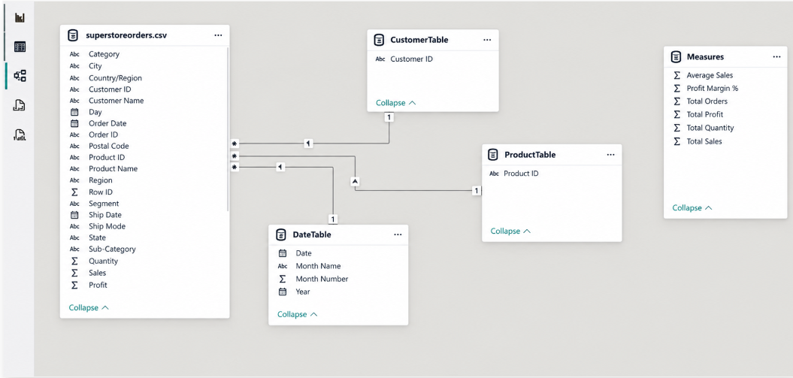.

5. Date Dimension Setup
A custom Date Table was engineered incorporating the following attributes:
Calendar Date
Year
Month Name
Month Index Number
This table was linked directly to the primary Order Date field to enable seamless time-intelligence capabilities.
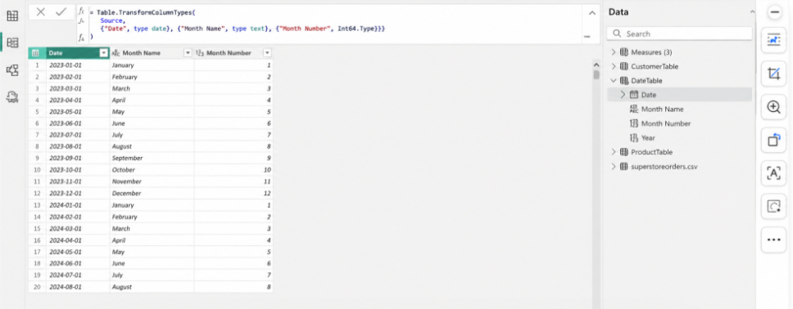

6. Key DAX Measures
The analytical model utilizes several custom dynamic measures created with DAX:
Total Sales
Total Profit
Total Orders
Total Quantity
Average Sales
Profit Margin %
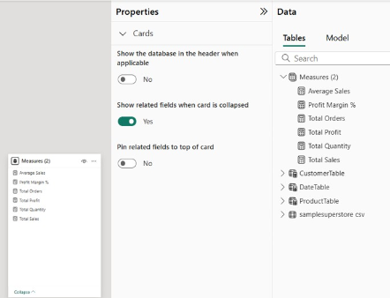

7. Dashboard Architecture
The reporting layout incorporates key interactive elements:

KPI Scorecards for top-level business health metrics.
Category Sales Distribution Chart for product breakdowns.
Regional Profitability Chart for geographical comparative analysis.
Sales Trend Line Chart for historical timeline analysis.
Interactive Slicers for customized slice-and-dice capability.
Decomposition Tree Visual for root-cause data exploration.

8. Key Analytical Insights
The complete dashboard facilitates high-level and granular evaluations of total earnings, margin efficiency, top-performing product groups, regional contributions, buyer demographics, and temporal revenue trends.

9. Business Advantages
- Real-time interactive exploration
- Intuitive data representation
- Rapid cross-comparison of revenue vs. profitability
- Dynamic filtering options
- Advanced time-based intelligence

10. Conclusion
This initiative successfully demonstrates the full analytics capabilities of Power BI—ranging from ETL data transformation and dimensional modeling to DAX formulation and interactive visual dashboard development using the Superstore Sales Dataset.

11. Tools & Technologies Applied
Microsoft Power BI Desktop, Power Query Editor, Data Analysis Expressions (DAX), KPI Scorecards, Custom Charts, Dynamic Slicers, and Decomposition Trees.

